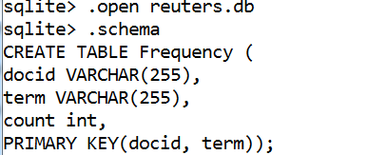

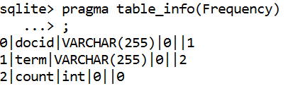

1a.

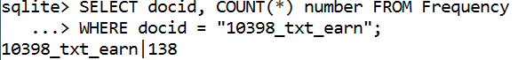

1b.

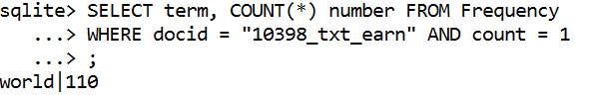

1c.

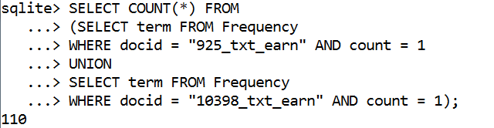

1d.

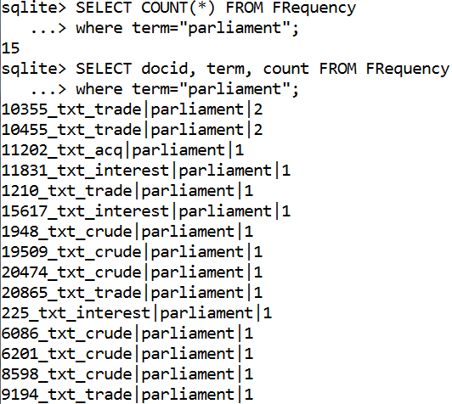

1e.

2264 unique doc_id



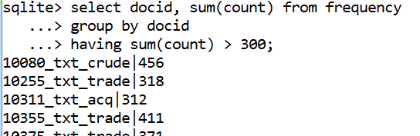

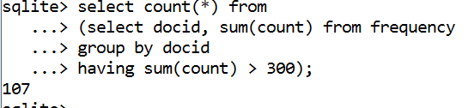

1f.

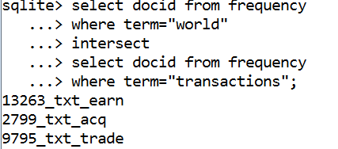

2g.

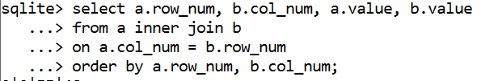

For actual product: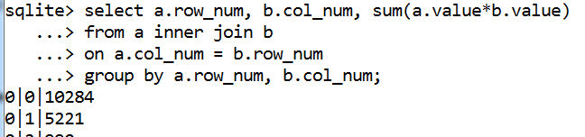

3h.

A*AT

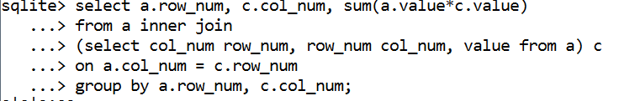

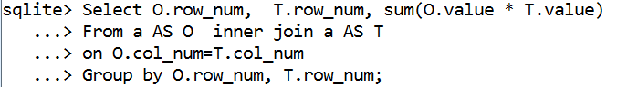

Select O.row_num,  T.row_num, sum(O.value * T.value)    
From a AS O  inner join a AS T  
on O.col_num=T.col_num  
Group by O.row_num, T.row_num;